A TECHNICAL REPORT ON
STUDENT’S INDUSTRIAL WORKS EXPERIENCE SCHEME (SIWES)

AT
MINISTRY OF WORKS AND HOUSING,
MAKURDI, BENUE STATE

FROM: 6TH OCTOBER, 2023
TO: 29TH JANUARY, 2024

BY
ANANDE MULEGA FESTUS
(ET/CE/ND/22/031)

SUBMITTED TO THE DEPARTMENT OF CIVIL ENGINEERING TECHNOLOGY, SCHOOL OF ENGINEERING, IN PARTIAL FULFILLMENT OF THE REQUIREMENT FOR THE AWARD OF NATIONAL DIPLOMA (ND) IN CIVIL ENGINEERING TECHNOLOGY, FEDERAL POLYTECHNIC, MUBI

MARCH, 2024

DEDICATION
This work is dedicated to God Almighty the maker of heavens and Earth, the giver of life and wisdom and to my beloved parent Mr. and Mrs. Anande Ikyuior and my beloved brother Mr. Toryira Anande and all my family members who work hard to support me.

ACKNOWLEDGEMENTS
I wish to acknowledge God Almighty for his infinite goodness, mercy and protection over my life through this training and professional program at large.
In official way I wish to acknowledge my beloved parents Mr. and Mrs. Anande Ikyuior for her loving and wonderful support over the phase of the event and my beloved brother Toryira Anande and all my family members and friends who work hard in contact to support and ensure that he program is rated successfully and I pray that may God in his infinite mercy, guide, bless, enrich, protect and support them in the ways of their life and health status, likewise financially encounter them with supernatural break-through in all phase of life.
I also wish to acknowledge my SIWES Coordinator in person of Engr. Alheri Jacob, supervisor Engr. Abdulhamid Mohammed for ensuring that she guide me in all buoyancy of industrial training.
I faithfully, acknowledge my Head of Department in person Engr. Yakubu Mamman Wakawa and all the staff of Civil Engineering department together with my fellow course mates for their support to enhance this training a successful one. I pray that may God continue to bless and support them financially, academically though out their life time through Christ the Lord. Amen.

ABSTRACT
This technical report is based on the experience gained during my four (4) month attachment, which covers all the experience gained. The chapter one covers history of ITF, benefit of ITF, Aim and Objective, chapter two covers the introduction to site work, chapter three covers preparation of sub-grade and drainage construction, while chapter four covers the conclusion and recommendation and Lastly the references.

TABLE OF CONTENT
TITLE PAGE………..…………………………………………………………..i
DEDICATION ii
ACKNOWLEDGEMENTS iii
ABSTRACT iv
TABLE OF CONTENT v
CHAPTER ONE 1
1.0 INTRODUCTION 1
1.1 MEANING OF ITF 1
1.2 OBJECTIVE OF ITF 1
1.3 AIMS OF ITF 2
1.4 MEANING OF SIWES 2
1.5 OBJECTIVE OF SIWES 2
1.6 AIM OF SIWES 3
1.7 SIGNIFICANCE OF SIWES 3
CHAPTER TWO 4
2.1 HISTORY OF THE ORGANIZATION 4
2.2 ORGANIZATIONAL CHART 5
CHAPTER THREE 6
3.1 INTRODUCTION TO SITE 6
3.1.1 CONDITION OF THE SITE 6
3.1.2 EARTH MOVING PLANT 6
3.2 PREPARATION OF SUB-GRADE 11
3.2.1 CONSTRUCTION OF SUB-GRADE 11
3.2.2 DRAINAGE CONSTRUCTION 12
3.2.3 PURPOSE OF DRAINAGE CONSTRUCTION 12
3.2.4 ARRANGEMENT OF DRAINAGE SYSTEM 13
3.2.5 HAND EQUIPMENTS, MATERIAL AND MACHINE USED IN DRAINAGE CONSTRUCTION 13
3.2.6 STAGES IN DRAINAGE CONSTRUCTION 14
3.3 RECONNAISSANCE SURVEY 15
3.3.1 SURVEY WORK 15
3.3.2 SETTING OUT 15
3.3.3 EXCAVATION 16
3.3.4 LEVELLING 16
3.3.5 REINFORCEMENT 17
3.3.6 CONCRETE MIXTURE 18
3.3.7 CONCRETE BASE FORMATION (BLINDING) 19
3.3.8 ARRANGEMENT OF PANEL 20
3.3.9 DRAINAGE WALL CONSTRUCTION 21
3.4 DRAINAGE SYSTEM MAINTENANCE 21
CHAPTER FOUR 23
4.1 CONCLUSION 23
4.2 RECOMMENDATION 23
REFERENCE 24

CHAPTER ONE
- INTRODUCTION
The Student’s Industrial Work Experience Scheme (SIWES) is a skill training programme designed to expose and prepare students in institution of higher learning.
This skill is also meant to expose students to working manner of some organization in the country and give them the required experience and practical to know how to handle equipment and machinery that may not be found in their institution.
The SIWES programme is finance by the Federal Government of Nigeria through the industrial training Fund (ITF) board. In most case, the capital used is partially obtained from taxing the registered companies and the federal government donated the remaining funds. The SIWES as a cooperation between industrial and institutional of higher learning in Nigeria is a continuation of student studies.
  - MEANING OF ITF
The industrial training fund was established by the decree No. 47 of 8th October 1971, with the aim of promoting and encouraging skills and acquisition of skills in industrial and commerce with a view of generate a pool of indigenous manpower to meet the need of the economy of the country.
  - OBJECTIVE OF ITF
- Building of training facilities of its own in identified area of national need.
- The establishment of uniform national vocation and apprenticeship training scheme in the country.
- Bearing a proportion of direct cost of the Job and off-job training Nigeria employees.
- Organizing research students as support to other activities of the fund.
- Seeking the harmonized ITF no formal training programme with the curricular formal education institution.
  - AIMS OF ITF
The aims of ITF is for promoting and encouraging the requisition of skills in industrial and commerce with a view to generate a pool of indigenous trained manpower and sufficient to meet the need of the economy.
  - MEANING OF SIWES
The programme SIWES is the student industrial work Experience Scheme which is coordinated by the industrial training fund (ITF).
The scheme helps the students to be exposed to the practical knowledge that he might not get in school during his course of study.
  - OBJECTIVE OF SIWES
- To expose student to equipment practically.
- To provide knowledgeable and efficient graduates under each related fields
- To increase the number of skilled worker
- To bring cooperation between the employer and the estuation so as to work hand enhanced and to know what type of student to be produced and to what extent.
- To enable the students practice their profession even after school, not only at working level even personally.
  - AIM OF SIWES
- To help student to see practically what have been taught earlier in classroom.
- To reconcile theory work with that of practical.
- To enable students to practically take part in ensure greats production.
- To help student greatly to know the rule and regulation and procedure of the work.
  - SIGNIFICANCE OF SIWES
- It help student to gain job experience in life
- It provides an opportunity to student to pulling human relation forest by exposing students to actual working environment.
- It help student to be skilled and knowledgeable in handling industrial equipment and tool.
- It help students to apply principle taught in school successful on job assign to him/her.

CHAPTER TWO

2.1 HISTORY OF THE ORGANIZATION
The Benue state ministry of works and transport Makurdi was established in 1976 upon creation of Benue State, from the defunct Benue-Plateau State. The ministry is one of the important organs through which Benue State Government executes policies and programs for the benefit of the people of the state.
The ministry of works and transport Makurdi specifically have the responsibility of formulating and executing of projects in the state such as provision of basic amenities like urban and rural roads, transportation and housing for residential and so on.
The main activities of the ministry are
- Construction of roads and bridges
- Building of government houses.
- Supervision of contracts awarded to companies.
- Maintenance of roads.
- Maintenance of plants, vehicles and equipments.
- Maintenance of Government offices and houses

2.2 ORGANIZATIONAL CHART
c
PERMANENT SECRETARY

COMMISIONER

PLANNING & DESIGN
PLANNING, RESEARCH & STATISTICS DIRECTORATE

PROGRESS & MAINTENANCEE
CONSTRUCTION
LABORATORY & QUALITY CONTROL
ESTABLISHMENT&FINANCE DEPT.
CIVIL ENG. DIRECTORATE
TRANSPORT
& POWER
HOUSING
DIRECTOR
Figure 2.1: An organogram of Benue State Ministry of works and Transport with emphasis on Civil Engineering Directorate

CHAPTER THREE
EXPERIENCE GAINED DURING TRAINNG

3.1 INTRODUCTION TO SITE
A site is a place of construction where the work is undertaken, it is usually associated with engineering work, the site which is in Ministry of Works and Housing, Makurdi, Benue State

3.1.1 CONDITION OF THE SITE
When I reported for the programme in the ministry, the ministry attached me with the engineer supervising the site i.e. the resident engineer (R.E). the site have already resumed before I was taken to site, some works like survey chemege where already established with the pigs and also TBM where made too. The site was at the early stage which is earth moving/clearance.

3.1.2 EARTH MOVING PLANT
These is commonly used on construction sites to transport and place excavated soil before beginning earth moving works, there must be a plan for the amount of material that needs to be moved as well as where it will be moved to.
Generally, the choice of earth moving plant will depend on;
- The quantity of material to be moved
- The type and condition of the soil and the site
- The distance to be moved.
- The speed and turn-around time required.
- The size of the excavating bucket
Earth moving plants are;
- Dumper: This is the most suitable option for sites where large amounts of material needs to be transported over distances both on and off site. As shown in the figure 1 below.
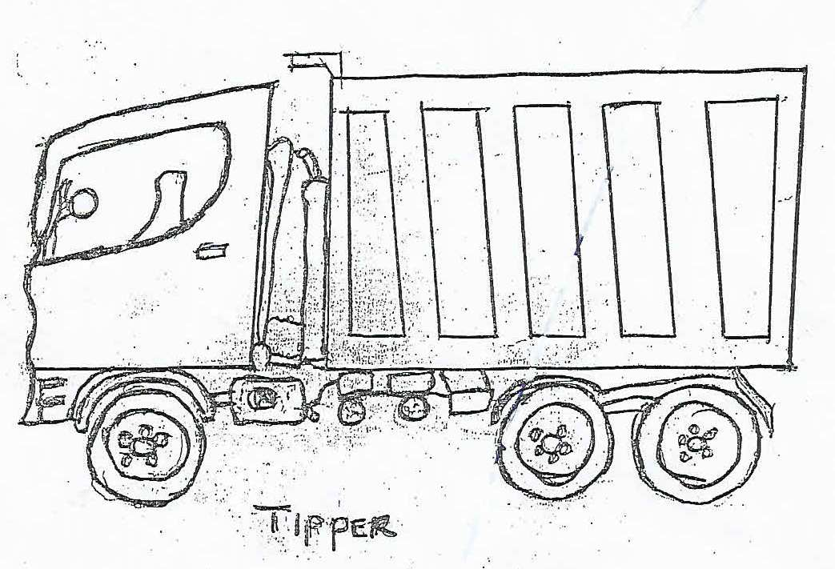
- Bulldozer: Bulldozers are track or wheel mounted with a forward-facing mould blade controlled by hydraulic rams. These are commonly use for stripping sites, reduced level digging and pushing earth from one point to another and also used for clearing vegetation and small trees. As shown in the figure 2 below
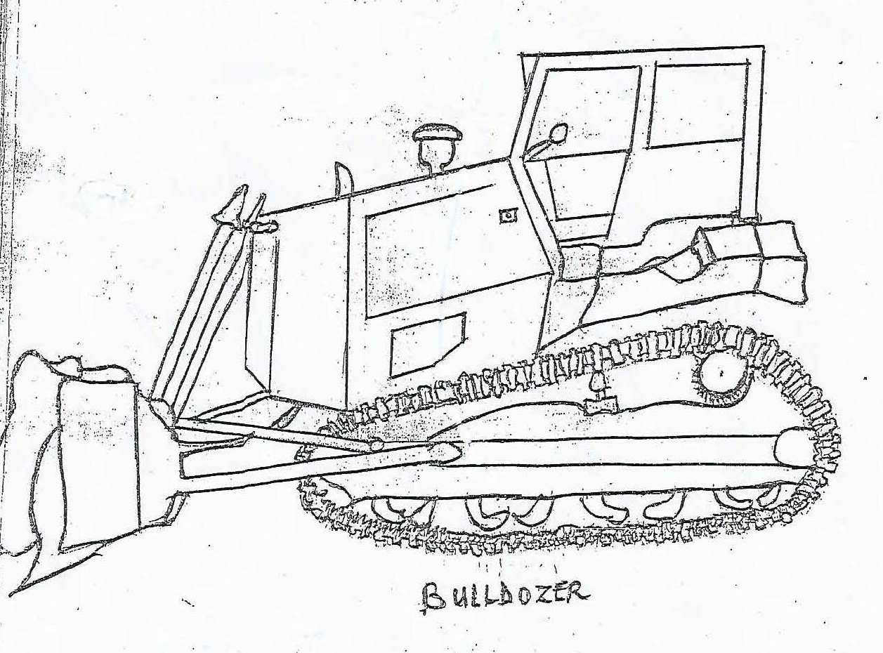
- Scrapper: These are capable of cutting, collecting and moving large quantities of soil across sites by the use of a scraper bowl for site stripping and leveling operation. One end of the scraper bowel is lowered to collect material whist the machine is moving when full the bowel is raised and the machine travels to the discharging area. As shown in the figure 3 below;
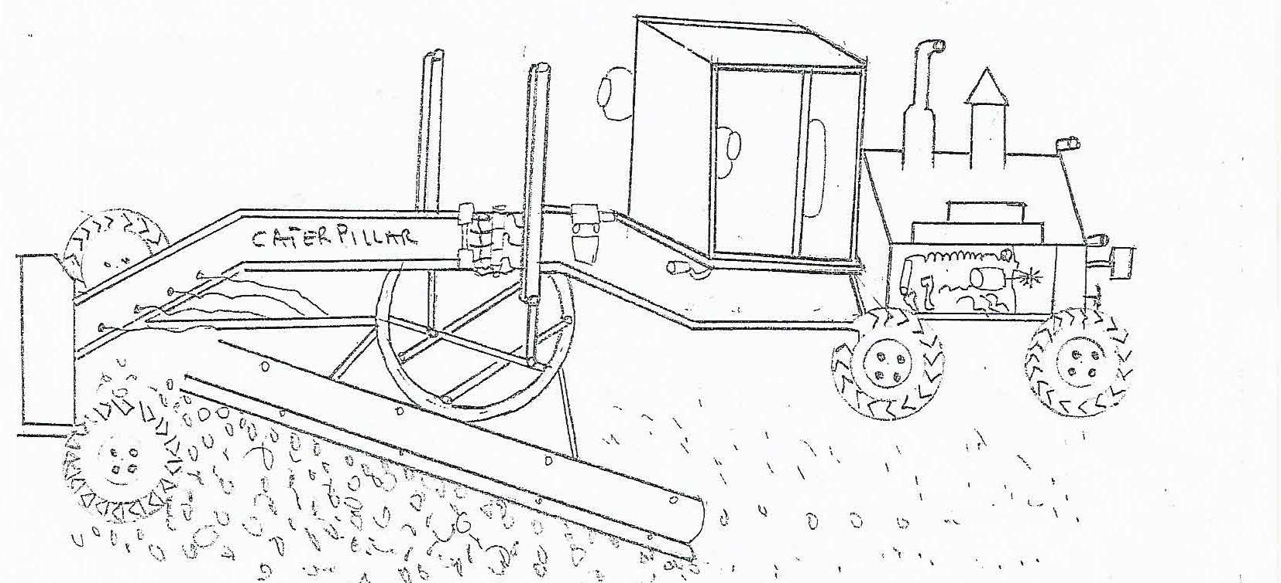
- Tractor (Loader): This is a machine having a front-mounted shovel bucket which is used to scoop up and raise loose spoil before depositing it into a transport vehicle such as a dumper. As shown in figure 4 below;
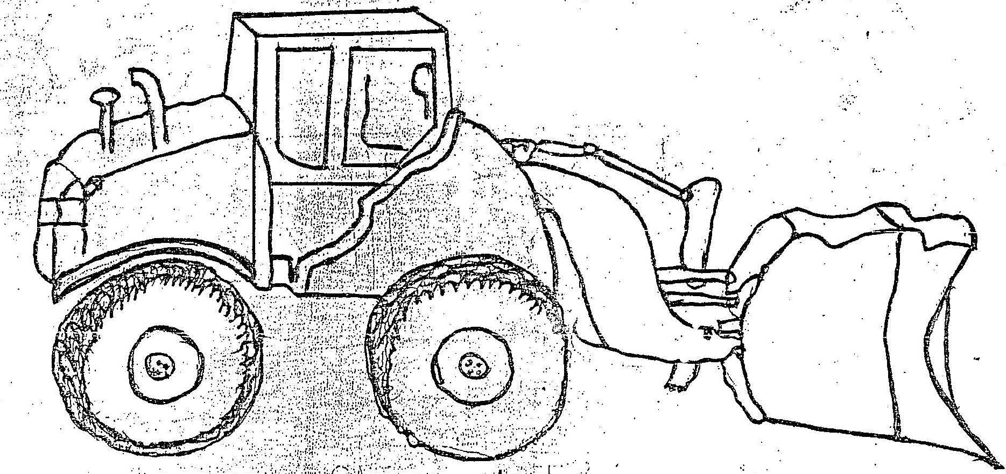

- Excavator: This is a machine used on construction sites to excavate and load most types of soil before beginning excavation work. As shown in figure 5 below;
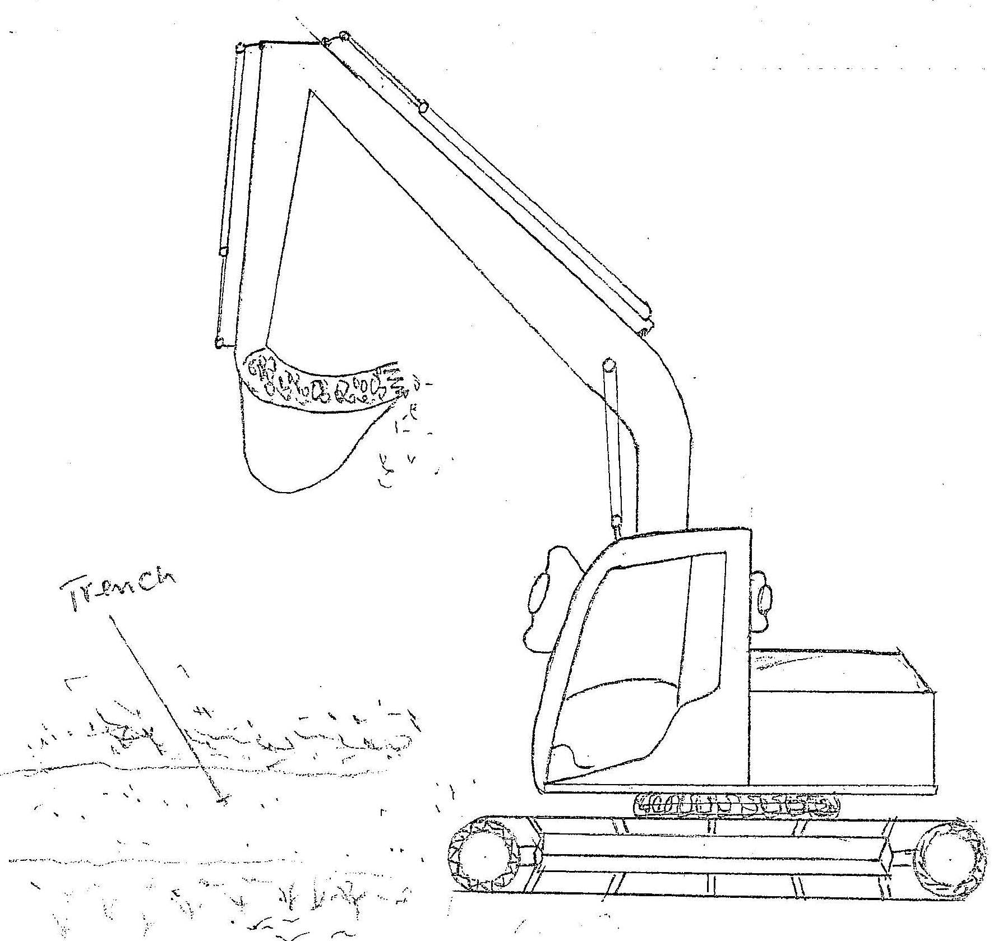

3.2 PREPARATION OF SUB-GRADE
According to Arthur W (2002), Sub-grade is the normal foundation level, the following works were undertaken to ensure a smooth sub grade which will withstand the load imposed on it.
- Water was spread on the sub-grade level
- Grader was used in leveling and shaping the sub-grade to remove all roughness.
- Water was also spread on the surface to smoothen it.
- Roller was used in compacting the sub-grade with 3 passes during the process no traffic was allowed into the formation prior the placement of the pavement

3.2.1 CONSTRUCTION OF SUB-GRADE
Sub-grade is the existing natural material underneath a road or pavement. It can also be imported if the material is found to be unsuitable for used as foundation layer.
Sub-grade was compacted before the construction of a road or pavement and usually stabilized by the addition of asphalt, lime, Portland cement or other modifiers. The sub-grade is the foundation of the pavement structure on which the sub-base is laid. The load bearing strength of sub-grade is measured by California Bearing Ration (CBR) test and other methods.

3.2.2 DRAINAGE CONSTRUCTION
Drainage is a channel that collects, conveys water or liquid waste from certain areas to a point of disposal. In construction, the depth and width of the drainage is designed depending on the anticipated volume of water that will be discharged through the drainage. Construction of drainage is one of the first work that is done during road construction.
An effective drainage system must ensure the provision of an economical and efficient means of carrying away water bodies in such way that is needed to be constructed with utmost care and accordance with building regulation, otherwise it can create a definite hazard to health.

3.2.3 PURPOSE OF DRAINAGE CONSTRUCTION
The purpose of drainage construction includes the following:
- To maintain stable base course;
- To discharge water from the surface of the road;
- To prevent pavement from destruction such as cracks, deformation etc. that may be brought by running water;
- For save guarding the sides of highway users.

3.2.4 ARRANGEMENT OF DRAINAGE SYSTEM
The arrangement of drainage was influenced by sewage arrangement; the layout of drainage system is stated as follows:
- Separation System: Foul water passes through on side of the drain to a foul sewer system. The surface water is conveyed to a separate water sewer or soak away.
- Combine System: Foul water from sanitary appliances, surface water from roads and paved areas discharge through a single drain to a combine sewer system.

3.2.5 HAND EQUIPMENTS, MATERIAL AND MACHINE USED IN DRAINAGE CONSTRUCTION
The equipment used in drainage construction are as follows (figure 6):
i. Excavator ii. Shovel iii. Concrete mixer
iv. Head pans v. Measuring Tape vi. Cement
vii. Gravel viii. Digger ix. Sand
x. Spirit Level xi. Wheel barrow xii. Water
xiii. Levelling Staff xiv. Rods xv. Levelling Instrument
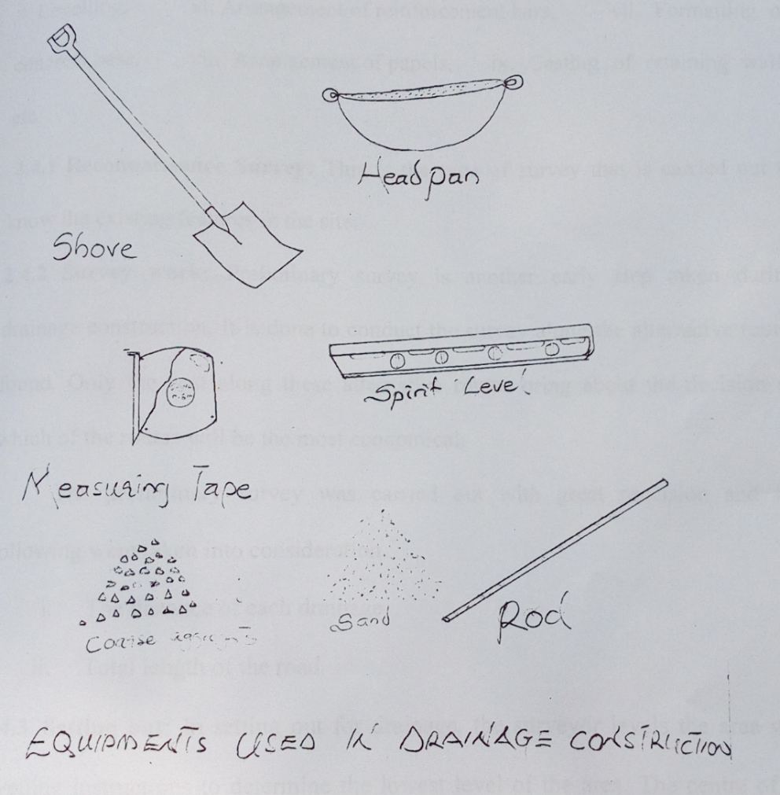
Figure 6: Some of the Equipments used in Drainage Construction

3.2.6 STAGES IN DRAINAGE CONSTRUCTION
The stages of drainage construction include the following:
- Reconnaissance survey
- Survey work
- Setting out
- Excavation
- Levelling
- Arrangement of reinforced bars
- Formation of concrete base
- Arrangement of panels
- Casting of retaining walls etc.

3.3 RECONNAISSANCE SURVEY
This is a type of survey which is carried out to know the existing features on the site.

3.3.1 SURVEY WORK
Preliminary survey is another early step taken during drainage construction. It is executed to conduct the survey along the alternative routes found. Only the cost along these alternatives routes bring about which routes that will be decided to be economical.
The preliminary survey was carried out with great precision and accuracy.
The following were taken into consideration:
- The distance of each drainage; and
- Total length of the road.

3.3.2 SETTING OUT
In setting out for drainage, the area is levelled to determine the lowest level of area by the surveyor. The lowest area when found was marked with a peg. Using the centered peg, the width of the drainage was set out by measuring half the width of the drainage to both sides of the centered peg, and two pegs were fixed at the two measured points which were 1000mm each from the centered peg. Using a rope, the distance of the drainage was defined from the two offset pegs, with the aid of builders square. A new peg was fixed and the exert position of the rope from the peg was determined with the aid of spirit level and digger was used to transfer it to the group. The Instruments which were used are; theodolite tripod stand, pegs, builders square, rope, spirit level, and digger.

3.3.3 EXCAVATION
Excavation is the loosing and removal of earth or rocks from its original position, and transporting it to spoiled bank. It was done immediately after setting out. The excavation was done by an excavator and the drainage trench was dug to a depth of 1000mm and a width of 1000mm.

3.3.4 LEVELLING
Levelling is a process of measuring the in length between two different points on the earth surface. It was done to level the difference in height between joints on the earth surface of the excavated trenches.
The instruments used in levelling are as follows:
- Theodolite
- Pegs
- Tripod Stand
- Suitable Graduated Staff

3.3.5 REINFORCEMENT
According to Burden T.4 and Mosely W.4 (1990); Reinforcement is used to take certain structural functions in a concrete work. The reason is because, concrete is weak in tension as such reinforcements takes all tensile stresses. On the other hand concrete is strong on compressive stresses.
The following are the main types of reinforcements used in drainage construction:
- Main bars (U-bars): Y12 at 200mm or at 300mm
- Distribution bars (runners): Y10 at 200mm or 300mm
Y12 at 200mm or 300mm and Y10 at 200mm or 300mm simply means the bars are at 12mm and 10mm diameter respectively and are placed at 200mm or 300mm intervals respectively. The reinforcements used during my SIWES were Y12 at 300mm as shown in figure 7 below.
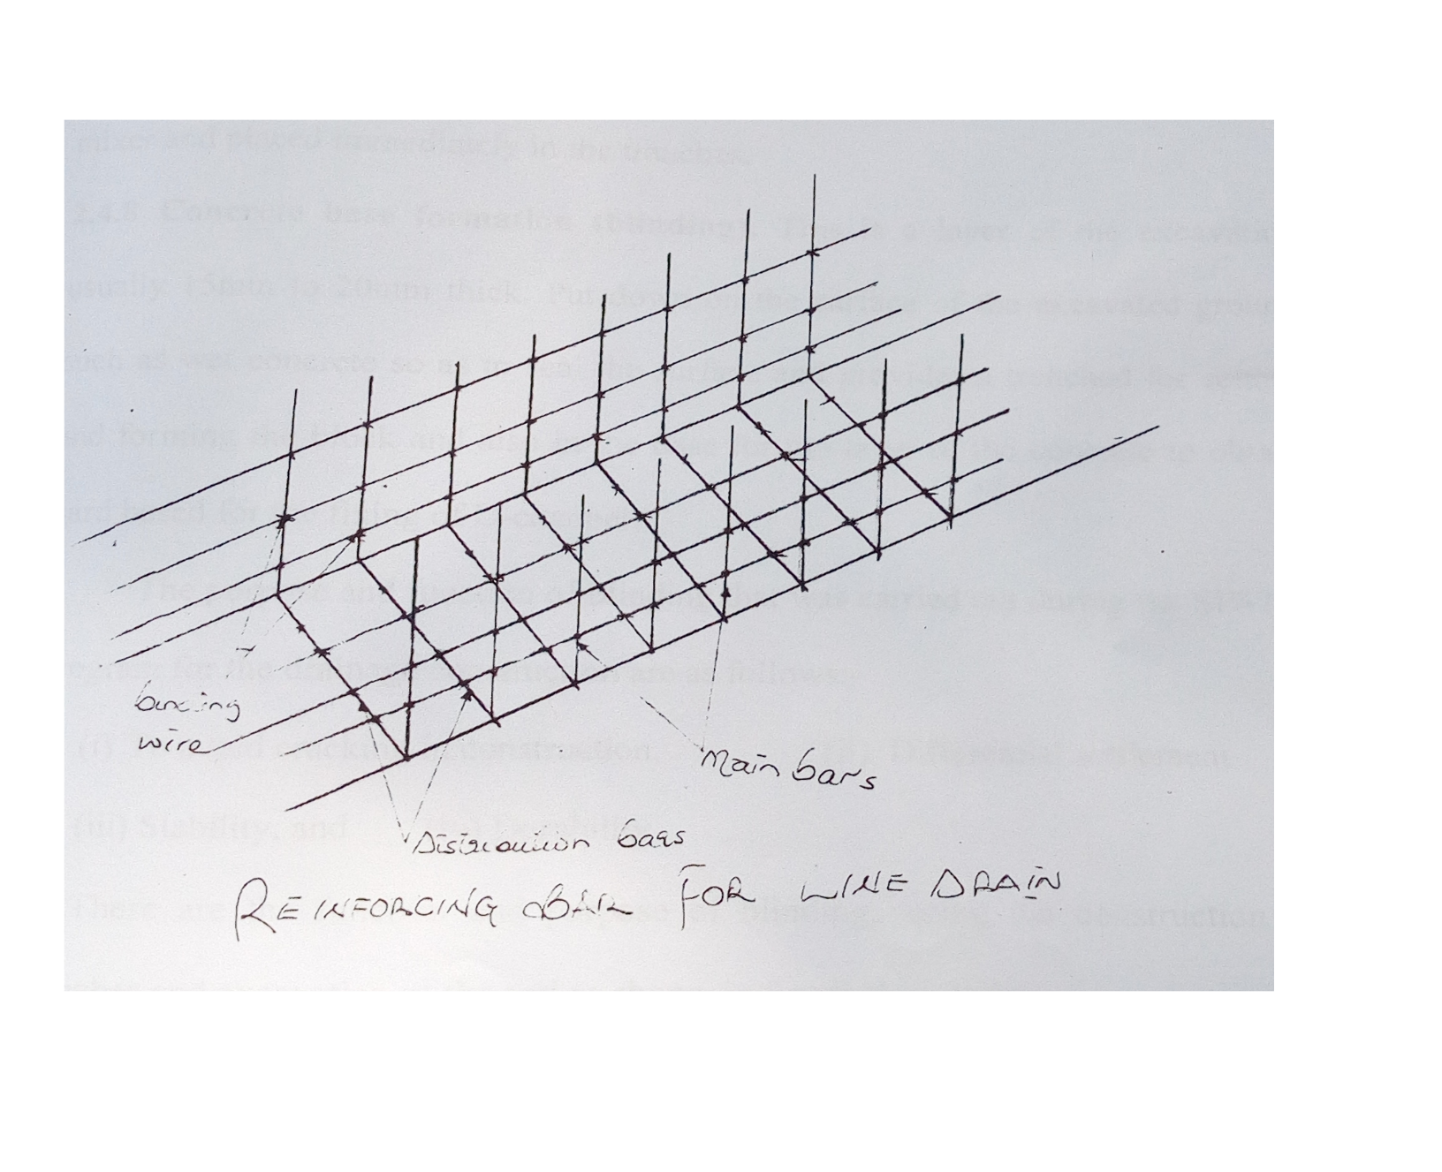
Figure 7: Reinforcement Bar for Line Drain

3.3.6 CONCRETE MIXTURE
Concrete is a mixture which comprises of sand, cement, coarse/fine aggregates, water and other required materials that may be used in certain cases such as drainage, culverts and bridges etc. The concrete can be mixed either manually or using machine.
The concrete used during the drainage construction was mixed on the using the cement mixer and to the ratio 1:2:2, which means 1 part cement to parts of sand to 2 parts of gravel but in some situations whereby the concrete mixer does not seem to be balanced materials such as sand or gravel can be added to balance the mix. The concrete was transferred to the site using wheel barrow and placed immediately in the trenches.

3.3.7 CONCRETE BASE FORMATION (BLINDING)
This is a layer of the excavation usually 15 to 20mm thick. Wet concrete is put down on the surface of the excavated ground so as to seal the surface and provide the trench for setting and forming the block and also in the base for the layer of the concrete to obtain hard based for the fixing of U-channel.
The purpose and function of blinding that was carried out during my SIWES program for the drainage construction are as follows:
- To avoid cracking in construction;
- Differential Settlement;
- Stability; and
- Durability.
These are the function and purpose of blinding during the construction of trenches and excavation of the soil as shown in the figure 8 below.
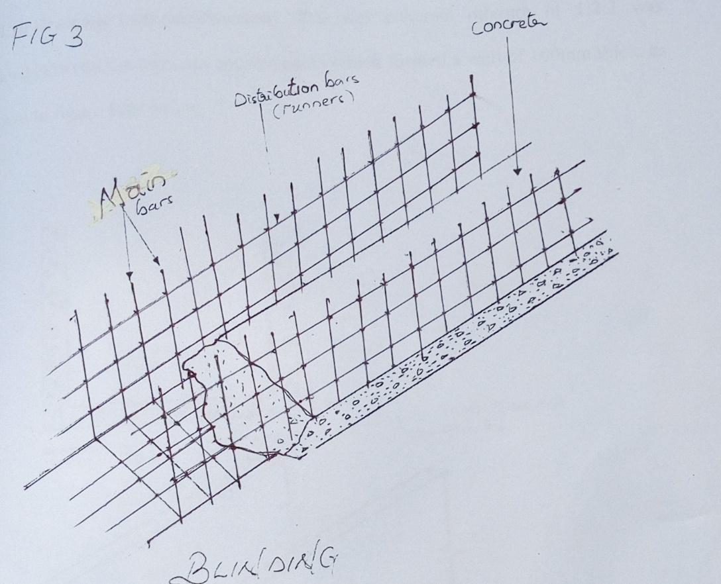
Figure 8: Concrete Base Formation (Blinding)

3.3.8 ARRANGEMENT OF PANEL
A panel is a strip of wood used to construct retaining walls of drainage. Before the arrangement of the panel (which is a metal panel), it was ensured that the concrete base was dated. The panel formed has a 150mm opening with the reinforcement bars in it, so that when the concrete is cast it will form a wall of 150mm thick.

3.3.9 DRAINAGE WALL CONSTRUCTION
The wet concrete mixture of 1:2:4 (or a suitable mixture with equal proportions of materials) were placed between the trenches and the panel which formed a wall of 100mm thick.

3.4 DRAINAGE SYSTEM MAINTENANCE
A standard and true drainage can be maintained based on the following steps when properly and adequately followed strictly:
- Conduct inspections more frequently during the wet season for problems areas where trash or sediment accumulates more often.
- Clean and repair when needed.
- Keep accurate logs of the number of catch basin cleared.
- Record the amount of waste collected regularly.
- Store waste collected from cleaning activities of drainage system in appropriate containers or temporary storage units/sites in a manner that prevents discharge into the storm drains.
- Dewater waste and outflow into the sanitary sewer if permitted.
- Water should be treated with the appropriate filtering devices prior to discharge to the sanitary sewer.
- If discharge to the sanitary sewer is not allowed, water should be pumped or vacuumed into a tank and properly disposed of.
- Do not dewater near a storm drain or stream.
- Except for small communities with relatively few catch basins that may be cleared manually, most municipalities will require mechanical cleaners such as vacuums or buckets.

CHAPTER FOUR

4.1 CONCLUSION
The student industrial work experience scheme (SIWES) programme has expose me to bridge the gap between theoretical and practical aspect in civil engineering work. It also shaped me in acquiring knowledge and skills from the firm furthermore, it allows me to exercise my human relationship in the society by preparing me for meaningful and productive employment in future.

4.2 RECOMMENDATION
During the SIWES programme, I encountered some problem which are my recommendation;
- The industry should provide accommodation and also ensure that the health and security of the students on industrial attachment is provided.
- The government should increase the SIWES allowance and should be paid on time after the industrial attachment.
- The programme should continue from generation to generation respectively.

REFERENCE
Arthur Wignall, Peter S. Kendrick and Roy Ancill (2013) Roadwork Theory & Practice 2ND Edition
Bungey J.H and W.H Mosley (1990); Reinforced concrete design. Macmillan press London, fourth edition.
Burgen T.4 and Mosely W.4 (1990), Reinforced Concrete Design, Macmillan Press Limited, London, PP 275-569.
Neil Jackson and Ravidra K Dchin (1996); Civil Engineering material Macmillan press London Limited fourth edition.

